**Salesforce, ESM, and the Lead-to-Cash Cycle**  
Salesforce gives you many tools to help manage your lead-to-cash cycle. Click on the information icons on this Sales home page example to find out more.

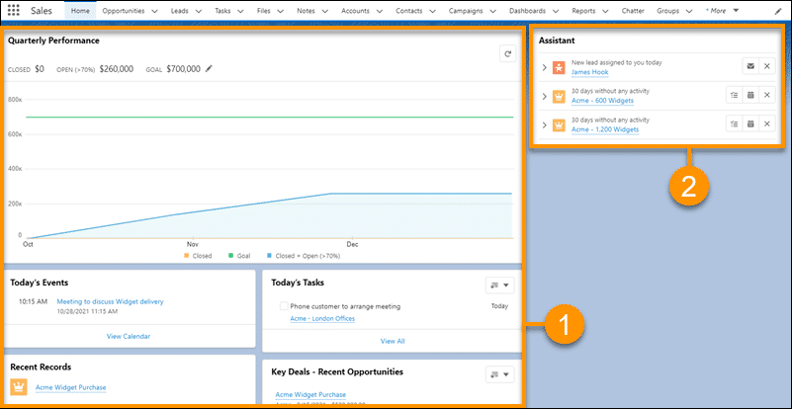

Depending on the license purchased by your organization, Salesforce also integrates with Tableau CRM to give you deeper insights into your orders, sales, and performance.

ESM is the application within Salesforce responsible for accurately creating your B2B opportunities, quotes, and orders, and then submitting validated orders to your order-management and fulfilment systems.

ESM provides a communications-industry-specific order capture flow for the multi-subscriber and multi-location quotes and orders that large enterprises often need. The solution uses information created in other steps in the lead-to-cash cycle, including customer data entered into Salesforce CRM. ESM also passes information out to those systems as part of the quote-and-order process.

How does ESM fit with the three core tasks in the lead-to-cash cycle? Click on each numbered task to take a look.

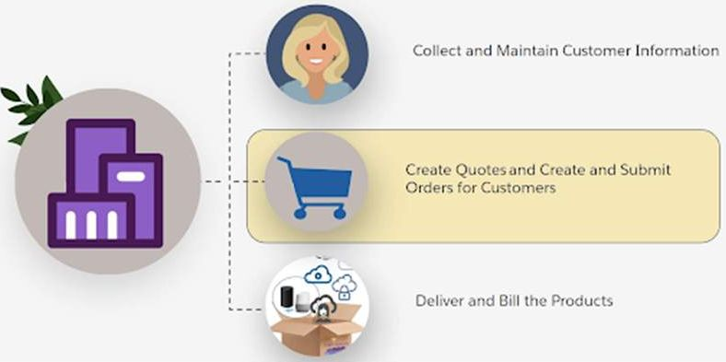

If you already use Salesforce in your lead-to-cash cycle, you'll recognize some familiar terms, like account, opportunity, quote, and order. If you're confident with locating and using each of these record types in Salesforce, that's great! If not, complete the Trailhead trail linked in Resources once you finish this lesson. This will ensure you can locate and amend accounts, contacts, opportunities, quotes and orders, as you’ll be doing a lot of this soon!

ESM’s Order Flow  
You probably noticed some similarities between the ESM order process demonstrated and what you currently have in your company. Let’s take a closer look at the ESM order flow.

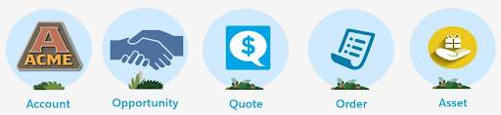

**1. Open the Account**

The first step in ESM's enterprise lead-to-cash flow is to open the account. The account holds information about the customer, including assets, which are products the customer ordered in the past. At this point, your customer may not have an account but may already have a lead created. In this case, you can convert the lead information into an account using standard Salesforce processes.

|  |  |
| --- | --- |
| 📝 | An account must have a status of Active to be eligible for quoted products. View the Details tab to ensure the account status is set to Active before continuing the quote-and-order process. |

So far, nothing is different - but take a closer look at your account details. Your customer is a large enterprise, so they have a business account. There may be many subscribers and locations associated with the account. When you create an enterprise order, ESM automatically creates the subscribers and locations as service accounts and associates them with the business account. To create the service accounts, ESM uses information uploaded as part of the quote process.

**2. Create an Opportunity**

You create an opportunity when your customer informs you they’re interested in a product or service. If the customer knows which offers they want, you can make a note on the opportunity record. The opportunity details are added to the account so you can review them later. As you can see here, the Salesforce Assistant on your Sales home page gives you reminders about any overdue activity on opportunities.

**3. Create a Quote**

Quotes provide details of the products and services requested by the customer, including prices. ESM uses price lists, which are assigned to Salesforce price books, to manage market-sector pricing. ESM also applies the business rules defined in Industries CPQ to ensure quotes are accurate and appropriate for the customer.

Convert the opportunity to a quote using the Create Enterprise Quote action button in the top right area of the account page.

You can take other useful actions during the quote process, including:

* Upload, group, and select locations and subscribers for a quote.
* Create proposals to send to customers.
* Convert quotes to orders.

ESM gives you a flexible way to build your customer solutions and quotes. Here are some examples.

1. Imagine your customer wants a quote for 20 different offices across the USA, for a range of products that are location dependent. In this situation, it makes sense to upload all the locations first, and then allocate the relevant products to the locations for quoting. As shown below, once the locations are uploaded ESM’s integration with Google Maps makes it easy to select the locations to allocate products.
2. Maybe some locations are in the same area? In this case, you can group locations to make product allocation easier.
3. Alternatively, your customer may have specific products they want to give to all their subscribers or locations. In this scenario, you can add your products first, configure them, and then associate the products with your subscribers or locations.
4. Here's another scenario. Your customer has 500 subscribers on a waiting list for the latest iPhone to be released next week. However, they estimate another 500 subscribers will want the new iPhones within the next month. The customer asks to order 1,000 new iPhones, but only gives you details of the 500 subscribers on the waiting list. You create a quote for the phones, upload and allocate 500 phones to those subscribers whose details you have, and leave 500 phones with no subscribers or locations allocated to them, all in the same quote.

Once you’ve developed an appropriate solution for your customer, ESM  generates and updates  proposals for your customer based on the quote contents. Enterprise customers often want to negotiate the pricing or some of the configurations. ESM offers frame-agreement pricing and manual-pricing adjustment to support the negotiation process. If your quote changes, you can simply regenerate the proposal to update it with the latest quote details.

**4. Create and Submit the Order**

Your customer is happy with the quote, and you've sent them a contract, which they've signed using CLM’s DocuSign feature. Now it's time to create and submit the order. In the quote record, click Create Order to generate an order from the quote details.

When you create an order, ESM creates a service account for each of the locations and subscribers specified in the quote. It then associates the service accounts with the customer’s business account.

Enterprise orders can be large and complex. To help your orders process more efficiently, ESM breaks your orders down into parent and sub-orders, grouping the orders together for processing.

Once your order is created and validated, you click Submit Order to route it to your order-management system. The Action column in the quote here shows what happens to the asset as part of the order process. You can check the orchestration tasks from ESM to see if the order process is running smoothly.

**5. View and Amend the Assets**

Once the order is submitted, the products and services requested are added to the customer's account as assets. As shown here, you can view the assets from the customer’s account page. Assets may be grouped to make them easier to navigate. Later, your customer can use Industries CPQ to amend their assets through asset-based orders.

What’s Different from Industries CPQ?  
Both Industries CPQ and ESM use the product models and rules set up in the shared catalog. With Industries CPQ, you create a quote and add products to it. Next, you configure, price, and validate the quote. At any point, you can see the offer pricing and overall quote pricing. The configure-price-quote process is the same with ESM, but ESM has these added features:

* Catalog-based browsing
* Inline offer display
* Promotion selection
* Patterns for associating products with quote members

Catalog-Based Browsing  
ESM extends Industries CPQ to give you catalog-style browsing. Pick the product category on the left to view the products for which the customer is eligible.

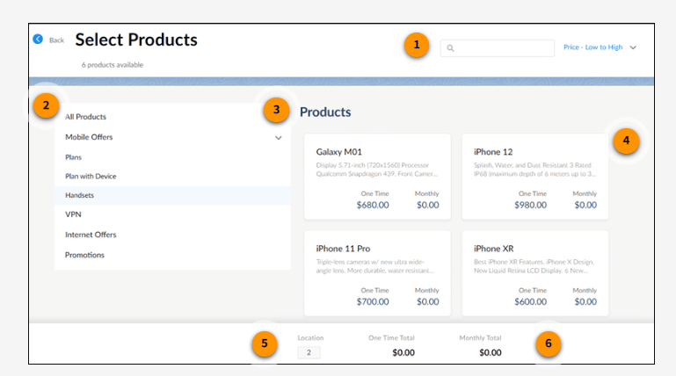

Some product categories, such as Mobile Offers, have subcategories to help you find products faster. Expand the categories to view any subcategories. Here you can see the Mobile Offers category expanded with a Handsets subcategory, which shows all the handsets available to the customer.

Notice the one-time total and monthly totals (6) for the quote displayed at the bottom of the page. Location (5) tells you how many locations are associated with the chosen product. You'll learn more about this later in the lesson.

Inline Offer Display  
Unlike Industries CPQ, ESM shows you full inline details for each product on offer in a tiled format. This minimizes the number of clicks required to view product information during product selection. This way, you can view the product name, description, and charges at a glance. Then click on a tile to add the product to your quote.

In this course, you use the standard ESM training playground and standard, out-of-the-box products: Business Internet, Business Mobile, and Business VPN. When you use your company org, you may find that your ESM implementation has amended or extended the standard product model in the shared catalog, so you might have slightly different configurations to those shown in the training org.

Promotion Selection  
In ESM, promotions also look slightly different from those in Industries CPQ

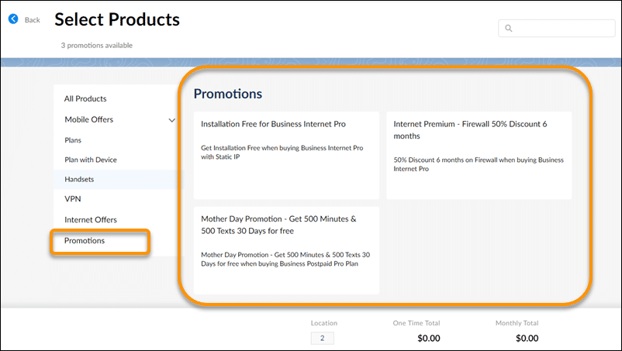

Promotions are shown as a category in the catalog and look similar to products at the point of selection.

Patterns for Associating Products with Quote Members  
The main difference between the ESM and CPQ quoting processes is the introduction of multiple subscribers and locations (quote members) and the ability to group quote members (quote groups). You have three different ways to add and configure products in ESM. You can:

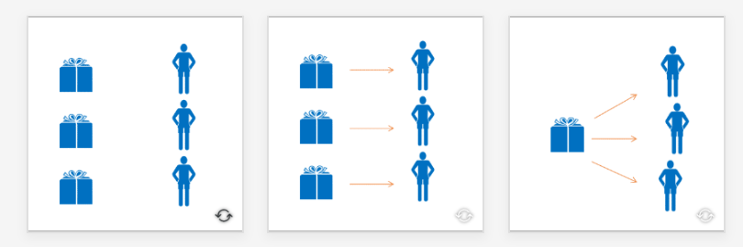

1. Add a product and configure it, without adding it to any quote group or quote members. For example, if your customer wants to create an order but doesn’t yet have the full list of subscribers or locations for that order.
2. Add a product to a quote member and configure the product. Use this approach when each quote member requires different products and configuration.
3. Add a product to a quote group and configure the product. Use this approach when a product is configured the same way for all quote members in a quote group. It creates just one line item in the quote and associates the line item with all members in the quote group. This way, each quote member gets a product with exactly the same configuration.

Digging into Your Accounts  
What do you usually do in your accounts space? Do you scan the Details section looking for customer contact information? Do you browse the Related section for order and asset details? You’ll probably still do these things when using ESM, but you’ll have these handy features to help you work faster: the Account Hierarchy viewer and the Asset Viewer.

Account Hierarchy Viewer  
Depending on your company’s implementation, your business accounts are likely to be associated with other account records, including a billing account and service accounts. Service accounts are created and assigned to the business account automatically by ESM when an order is created with multiple locations or subscribers.

You can view associated account records by selecting the View Account Hierarchy icon to the right of the account name in the Account tab.

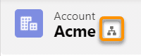

Here’s the account hierarchy for Acme, which shows all the associated service accounts, including office locations with orders placed. Click any of the locations to go to the service account record, where you can see more details, including any assets allocated.

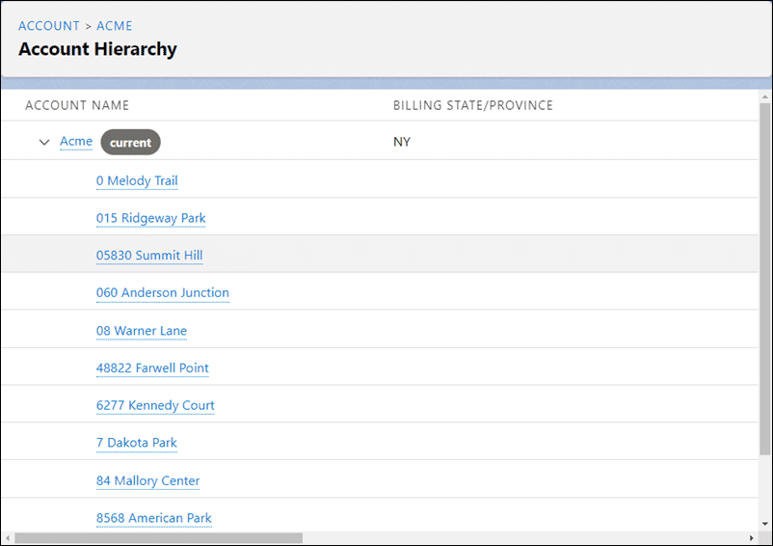

Return to the Acme account to see all of Acme’s assets. Either select Acme from the list, or use the breadcrumb trail in the Account Hierarchy header.

Asset Viewer  
You’ve placed many orders for your favorite large enterprise customer, Acme. How do you check what they’ve ordered? Go to the Asset Viewer on the account. Here you'll see all the products and services that have been ordered and assetized for the selected account.

The list of assets is huge, right? How are you going to locate the one asset the customer wants to update? The Asset Viewer in ESM gives you additional features to help you find exactly what you're looking for quickly and easily.

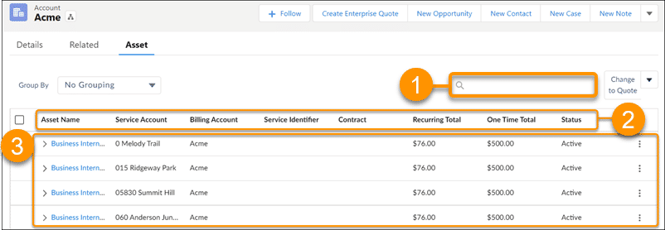

Notice the search bar at the top of the asset list (1). Type part of the asset name here, and click the search icon to locate all the related items in the asset list.

Hover your mouse over one of the column headings (2) in the asset list. Notice that an ascending ⬆ or descending ⬇ arrow appears to the right of the column heading. You can click a column heading to sort your asset list (3) in ascending or descending order by asset name, service account, billing account, service identifier, contract, status, or charge amount.

Click the chevron to expand an asset and view all the child items of the asset.

You can view your assets by group. Group options available out of the box are: asset name, service account, billing account, and status. Select the grouping option from the Group By dropdown list.

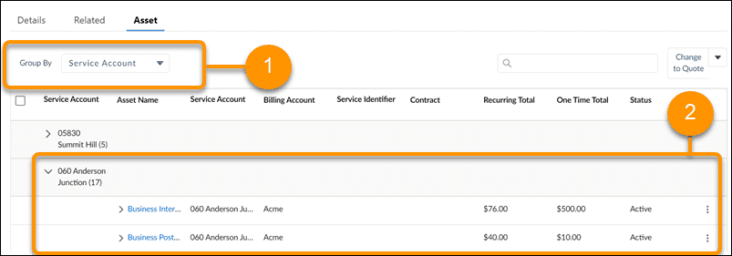

Here we chose to group assets by service account (1). You can see how Acme’s assets are grouped by service account (2).

Opportunities, Quotes, and Orders  
At the top of your Account page, notice the quick links to key information related to the account (1). Select the appropriate link to view account information, such as related orders, opportunities and cases.

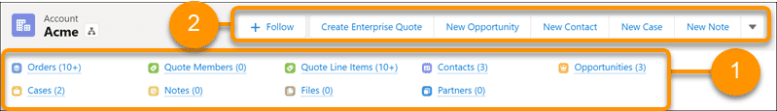

Use the action buttons (2) to create new opportunities and quotes. For example, click **Create Enterprise Quote** to start the wizard that guides you through creating a quote for the account using ESM.

Salesforce specifies that all quotes must be related to an opportunity. Before you create a quote, the first step in the quotation process should always be to ensure an opportunity is registered for the quote on the account. Click New Opportunity to add an opportunity to the account.

This is all pretty standard Salesforce stuff. However, when you take a look at one of the primary orders for your account, you'll notice things are a bit different. Here’s an example.

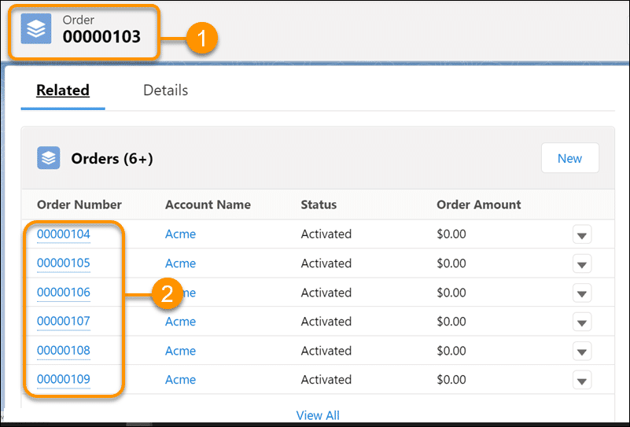

This is order 00000103, which was recently completed for Acme (1). When you select this order, notice the associated sub-orders (2). When you create an order, ESM creates a primary order, in this case order 00000103. Next, it separates sub-orders for each quote member.

Splitting the order into sub-orders grouped under a primary order gives you the flexibility to decide when your orders are processed:

1. You can submit the primary order to the order-management system using the Bulk Submit button. This submits all the sub-orders at the same time. ESM groups the sub-orders for processing before passing them to the order-management system.
2. Alternatively, you can submit groups of sub-orders or individual sub-orders to the order-management system when required by the customer. As the sub-orders are submitted and processed, their status is updated automatically.

**Review: The Lead-to-Cash Process**Before you dive into creating the solution, let’s review the lead-to-cash process and how the different Salesforce objects fit into that process.

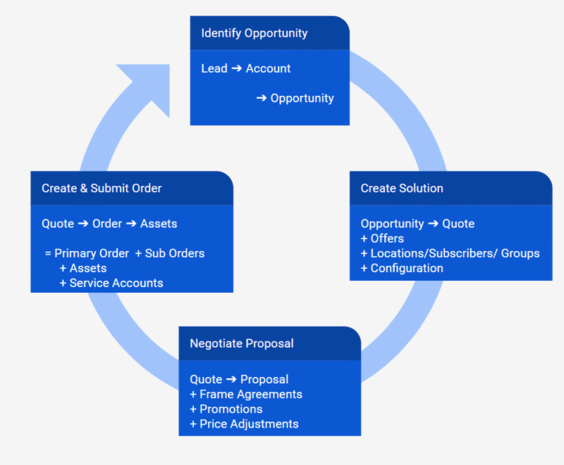

Quote-Building Basics  
How do you build an enterprise solution for your customer in ESM? Follow these seven key steps.

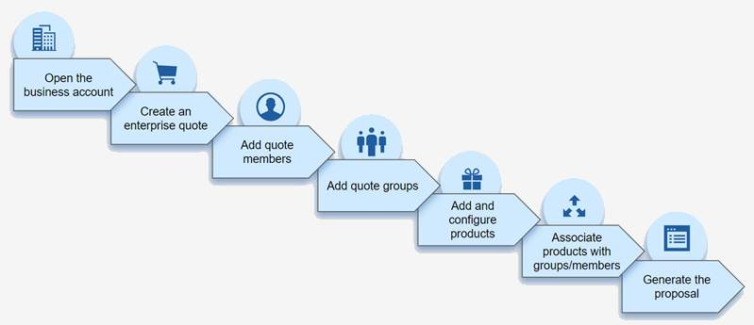

**Keeping it Practical and Flexible**

The step order (or "quote pattern") depends on the type of the solution you’re building and your current business practices.

Whichever way you choose, ESM helps you provide the right solution quickly.

Click here to see the different quote patterns used in ESM, before working through a practical example.

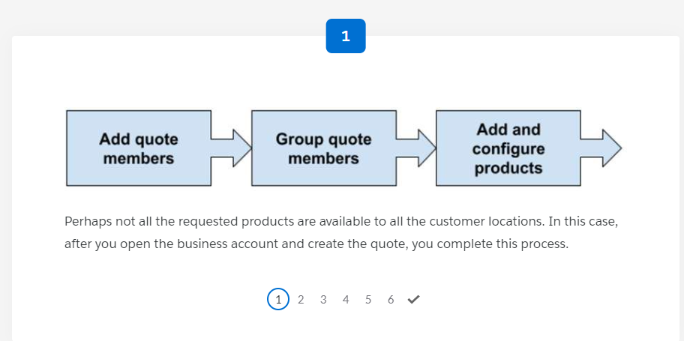

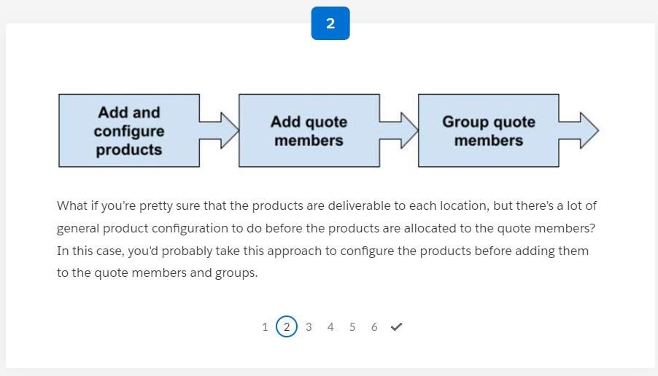

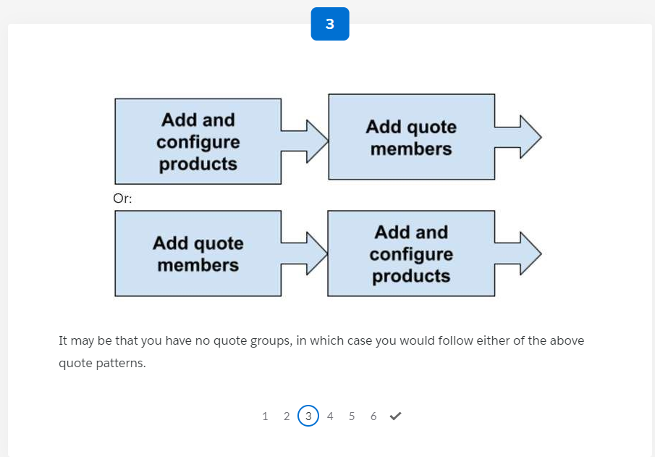

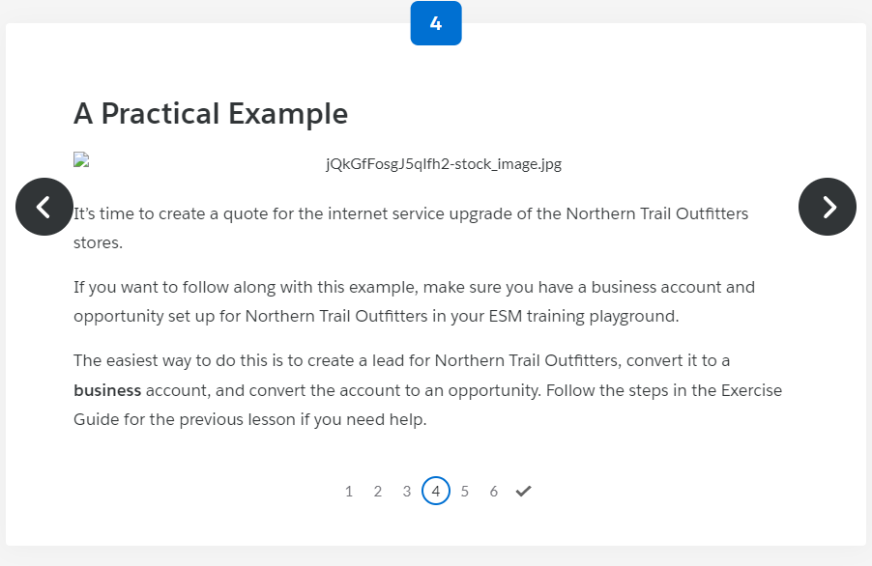

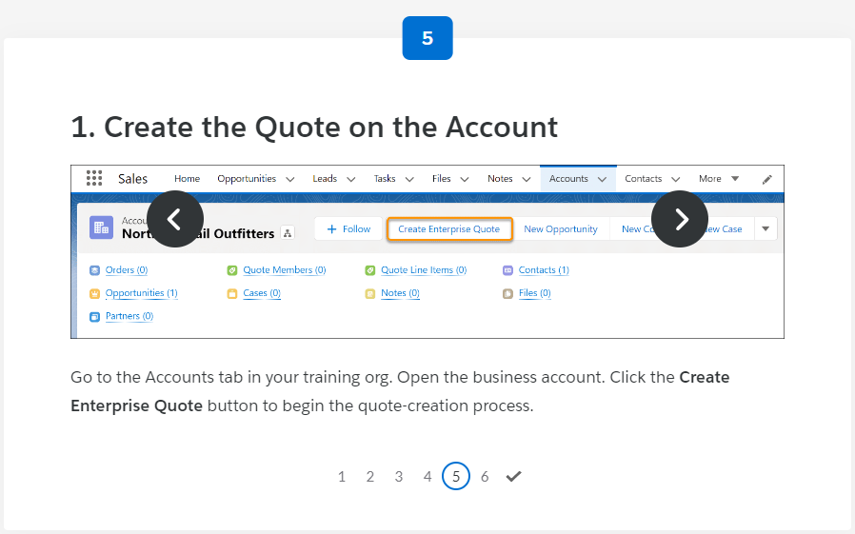

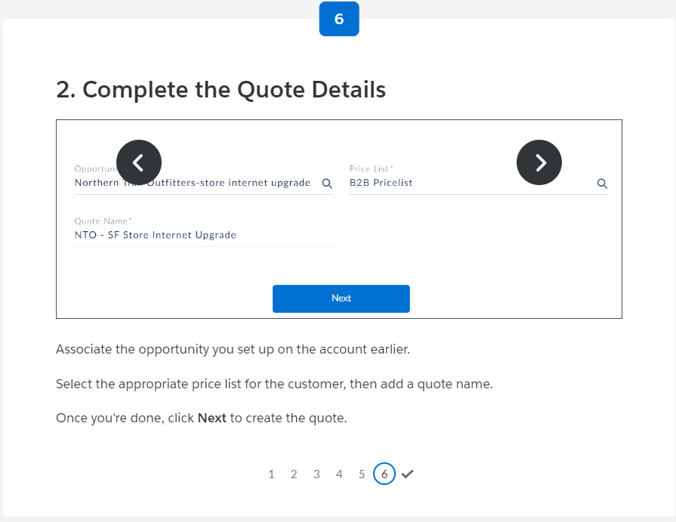

What are Quote Members and Quote Groups?  
For enterprise quotes, you often need to add products for multiple locations or subscribers to a single quote. In ESM, locations and subscribers are called *quote members*. You can type in the quote member details yourself, or you can bulk upload quote members to your quote using a CSV or XLSX file.

Enterprise quotes can contain hundreds of quote members. How do you manage these? Use ESM’s quote member grouping feature. You can add products and configure them for groups of quote members, as well as for individual quote members, to speed up the solution-building process.

In this lesson, you practice creating and managing your quote members and quote groups for Northern Trail Outfitters. First, ensure you have all the information you need:

* In the resources for this lesson, find a list of all the branch addresses in CSV format. The CSV file also has a column for branch size so you can group the branches.
* If you want to follow along with this example, make sure you’ve created an enterprise quote for Northern Trail Outfitters in your ESM training playground.

Manually Add Individual Quote Members  
Quote members are specific to a quote, so the first step in adding a quote member is to open the quote you created earlier for your customer.

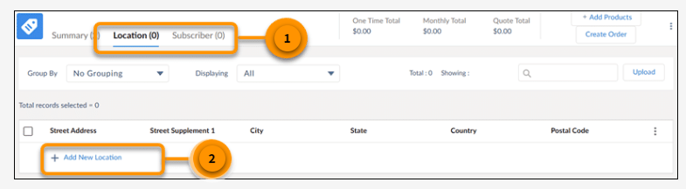

When you click  **+Add New Location** or **+Add New Subscriber**, a new row is added to your subscriber or location list.

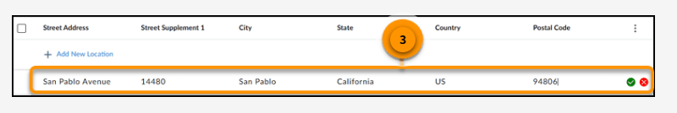

How easy was that?! But what if you need to add 10, 20, or 100 locations to your quote?  It would take you forever to type all of those details into the system. This is when bulk upload is a life saver.

ESM's Interactive Map  
If your ESM administrator has set up Google Maps integration, you can easily view and select your quote members using an interactive map. Use the Show Map slider to show and hide the map as needed.

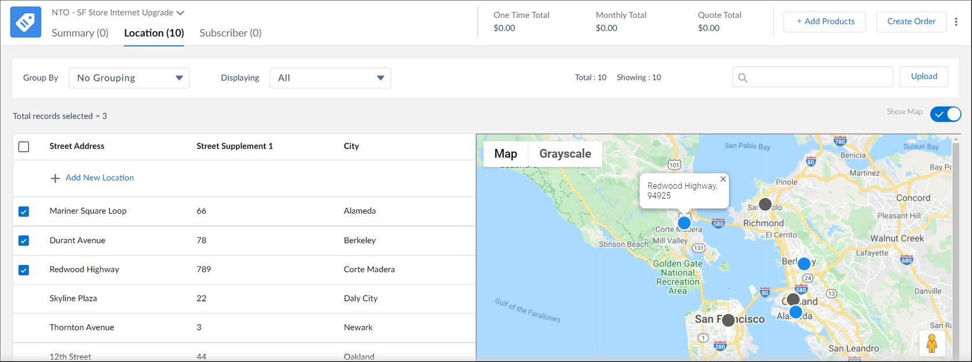

To select a location, click the corresponding dot on the map, or click the address from the list. Selected locations are shown with blue dots, and all other locations are shown with gray dots.  
Although this is a fantastically easy way to choose locations, you might not have Google Maps integration. Therefore, most of the examples in this course hide the interactive map.

Grouping Quote Members  
The Northern Trail Outfitters quote has only 10 quote members, but what if it had many more? In that situation, it’s helpful to group the quote members to manage them efficiently.

Your ESM org comes with a set of default groupings for locations and subscribers, such as grouping by city or state for locations. You can also create custom groupings to suit your requirements. For example, you could create a subscriber group for executives or a location group for offices in a certain region.

Each quote member can be part of only one custom group. For example, a subscriber can't be part of a management group as well as an executive leadership group. This ensures that you don't accidentally order multiple overlapping products for the same quote member in different groups.

Groups make it easy for you to manage quotes when you need to allocate specific products to multiple quote members. When working with groups you can:

* Add a list of subscribers or locations to a single group.
* Apply specific offer configurations to multiple members at one time.
* Regroup members, if required.

It’s not possible to customize products for individual group members. If you need to assign MSISDNs to subscribers, for example, add the products to each individual quote member. In this case, select the quote members individually, add the products, and then customize the quote line items. If you have five members, for example, and your product breaks down into five line items, the quote contains 25 line items, one for each member.

It might not seem like much, but with larger quotes this number can grow very quickly. If you use a quote group, each group has a quote line item, which makes the quote much easier to manage. Therefore, where you can, use groups - but be aware of the limitations.

Edit Quote Members  
At the start of this lesson, you created a quote member by typing the details directly into the quote member list. Use the same approach to edit quote members, which you can do anytime in the quote members list.

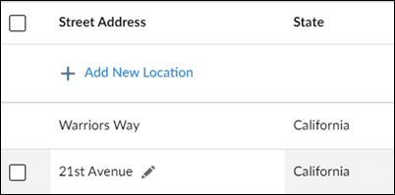

Hover over the data you want to change to show the pencil icon. Click the icon to edit the data. Once you make your changes, click outside the line you edited to see the updated details.

In this lesson, you learned how to manually create quote members and edit them, bulk upload quote members, and set up groups. In the next lesson, you'll learn how to associate products and configurations with quote members and quote groups.

In *Create Enterprise Solutions in ESM*, you learned how to create and configure a solution for your customer - but that’s only half the story! Here you’ll learn how to use ESM to negotiate configuration and to enrich your quote with order-specific information.

Amend Products in a Quote  
Negotiating an enterprise quote is an iterative process, so you usually need to amend the quote, update the proposal, and send it to your customer a few times before they agree to place the order. Here are the steps you follow when amending products. Click on each step to find out more.

**1. Open the quote**

To open an existing quote, go to the **Quotes**tab in ESM. If you can’t see the Quotes tab, use the More dropdown menu to show the tab. 

To locate and open your quote:

* Check the list filter. The **My Quotes** (1) filter shows all the quotes you've created. You can also open the dropdown list and choose **All Quotes**. Click the pin icon to the right of the list filter to pin your most commonly used list filter as the default.
* Still can’t see your quote? Try searching for it with some key words (2).
* Click the quote name (3) to open the quote.

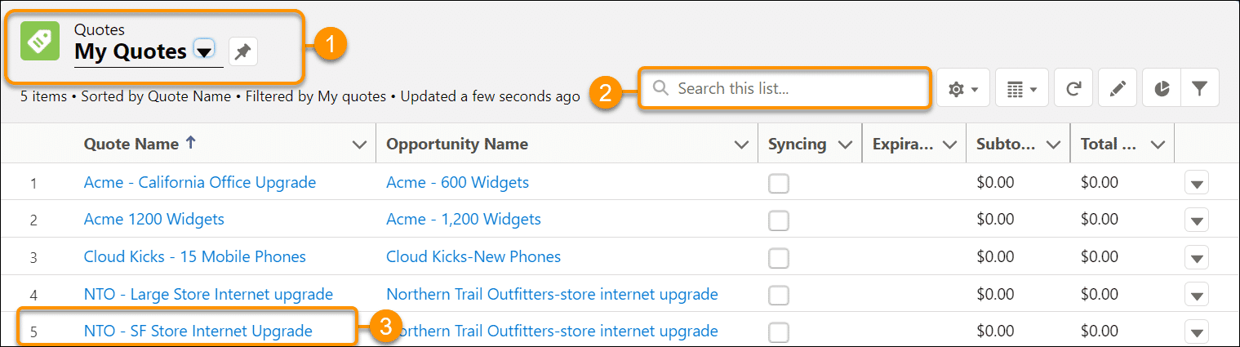

**2. Configure the enterprise quote**

Click **Configure Enterprise Quote** to edit your quote.

Your quote opens, ready for you to edit.

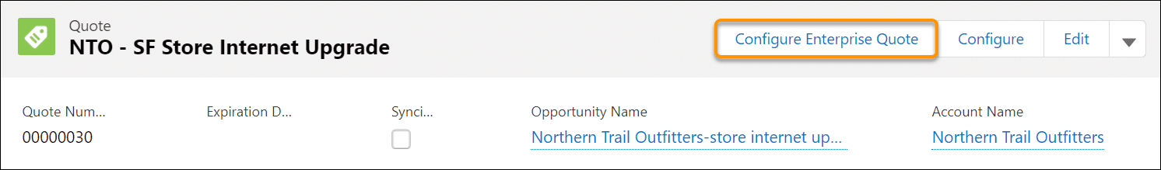

**3. Edit quote line items**

As part of negotiation, you may need to edit a quote to change product configuration or remove products.

1. Click the **Summary**(1) tab to show the quote summary.
2. In the row for the item you want to change, open the menu (2).
   1. If you want to delete a product, go to step 5.
   2. If you want to change the configuration, click **Edit**.
3. Update the configuration. For example, choose a new handset color.
4. Click **Add to Product** to apply the configuration changes and return to the quote summary. You’re finished editing the quote line item.
5. Click **Delete**. The product is removed from the quote. You’re finished deleting a product.

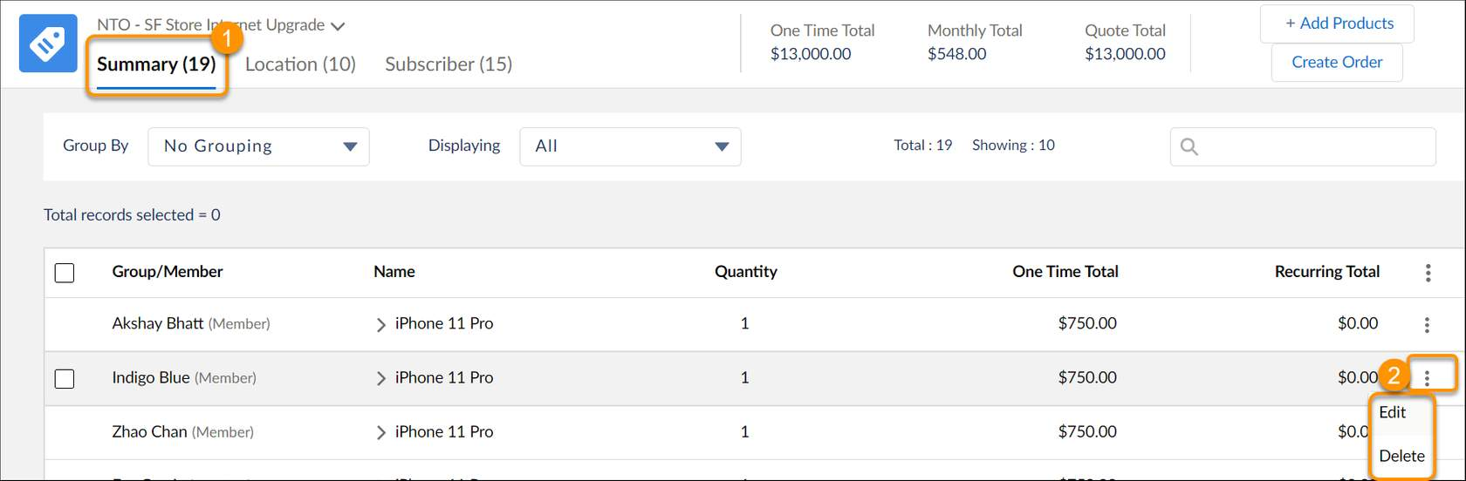

Quote Enrichment  
Consider information such as connection dates and assigned phone numbers. This information is generally not required when building the solution, and has no impact on pricing. However, it is required to place the order. It's therefore useful to add this information to the quote towards the end of the quotation process. This is called quote enrichment.

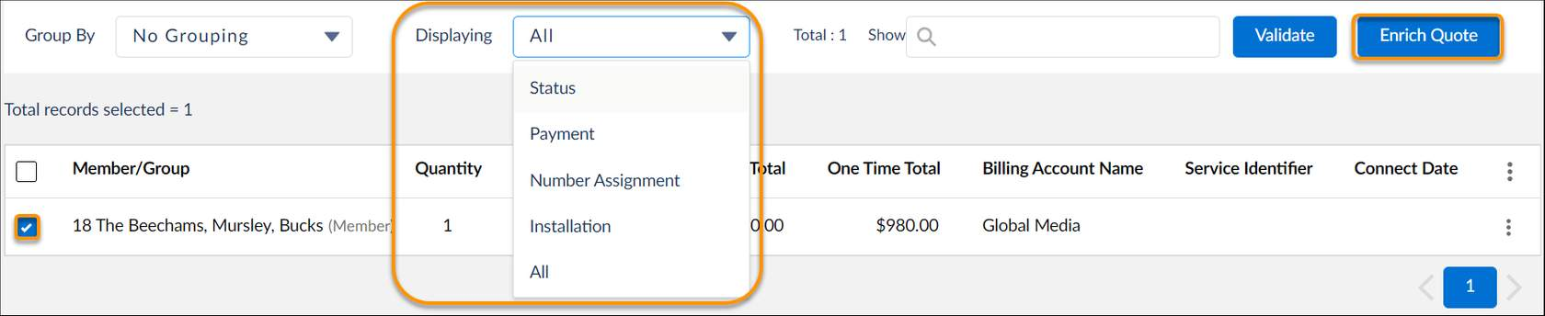

To enrich a quote:

1. On the **Summary**tab in the quote configuration, select the line items you want to enrich.
2. From the **Display**dropdown, choose the type of information to enrich. For example, for each selected line item, this could be:
   * **Status**- to check the validation status and validate the line items.
   * **Payment**- to update details for the billing accounts associated with the line items.
   * **Number Assignment**- to add information such as service identifiers.
   * **Installation**- to add details such as installation dates.
   * **All**- to complete all the enrichment information.
3. The appropriate columns are added to your quote item list in the Summary tab. Add the information to each line item as required.
4. If you want to add the same value to all the selected line items, click **Enrich Quote**. This will take you through a guided flow to make the amendments to multiple line items. Here's an example of a guided flow for installation.

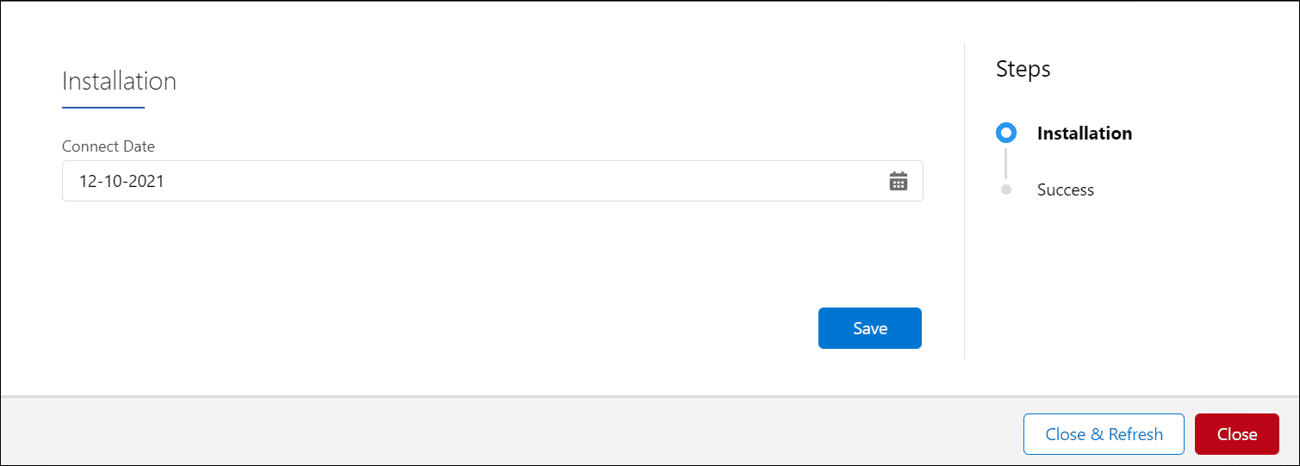

1. Make your changes and click **Save**or **Next** to continue through the steps of the guided flow.

Assign a Promotion to a Quote  
Your ESM product catalog includes some sample promotions. As with offers, you can assign promotions to members or groups, or you can just add a promotion without assigning it. Click on the steps here to see how it's done.

**1. Open the quote**

To open an existing quote, go to the Quotes tab in ESM. If you can’t see the Quotes tab, use the More dropdown menu to show the tab.

To locate and open your quote:

* Check the list filter. The **My Quotes** (1) filter shows all the quotes you've created. You can also open the dropdown list and choose **All Quotes**. Click the pin icon to the right of the list filter to pin your most commonly used list filter as the default.
* Still can’t see your quote? Try searching for it with some key words (2).
* Click the quote name (3) to open the quote.



**2. Configure the enterprise quote**

Click **Configure Enterprise Quote** to edit your quote.

Your quote opens, ready for you to edit.



**3. Select the quote members**

To assign a promotion to a subscriber or location, go to the **Subscriber**or the **Location**tab, and select the required subscribers or locations, either individually or by group.

Once your quote members and groups are selected, click **Add Products**. 

So far, the steps are the same as adding a new product.

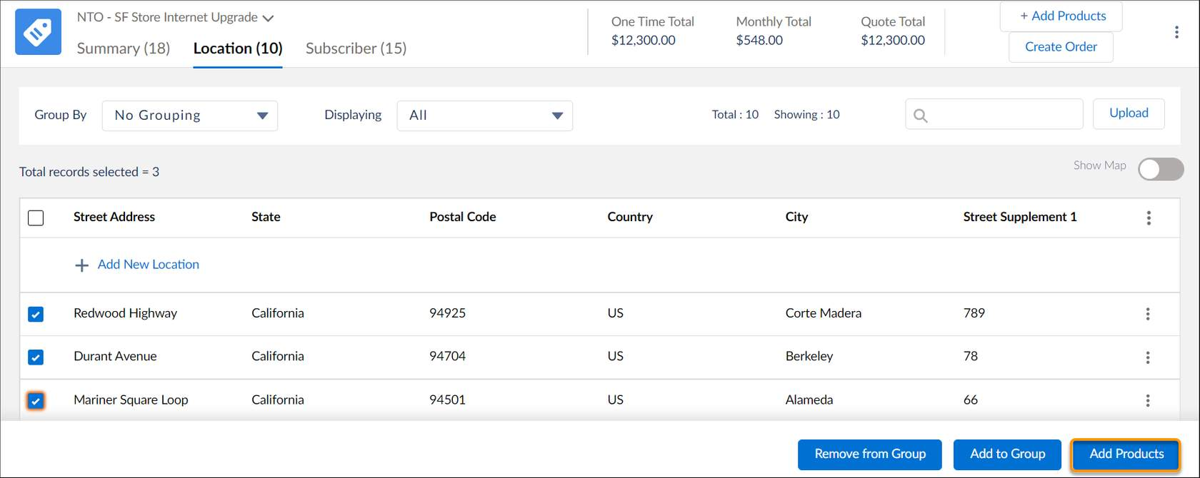

**4. Select the promotion**

Select **Promotions**from the catalog categories.

Click the appropriate tile to add the required promotion and all its associated products to the Cart.

|  |  |
| --- | --- |
| 📝 | What if you want to apply the promotion to products you've already added to the Cart? Add the promotion, and the promotional pricing and features are automatically added to the product that's already in the Cart, just as they do in Industries CPQ. |

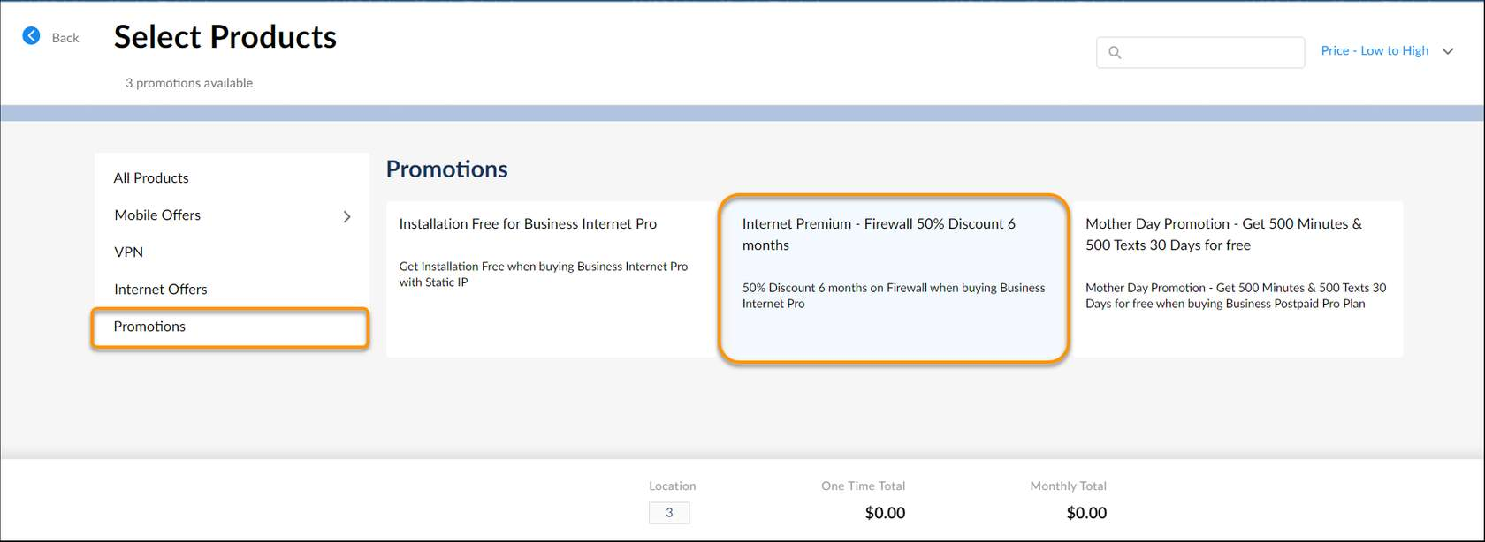

**5. Configure the promotion**

Configure the promotion to suit the customer’s requirements.

Notice this Internet Premium Firewall promotion features a half-price recurring charge for the firewall.

Click **Add to Location** to add the promotion to the locations selected. (Note: If you selected subscribers initially, this button would be **Add to Subscribers**).

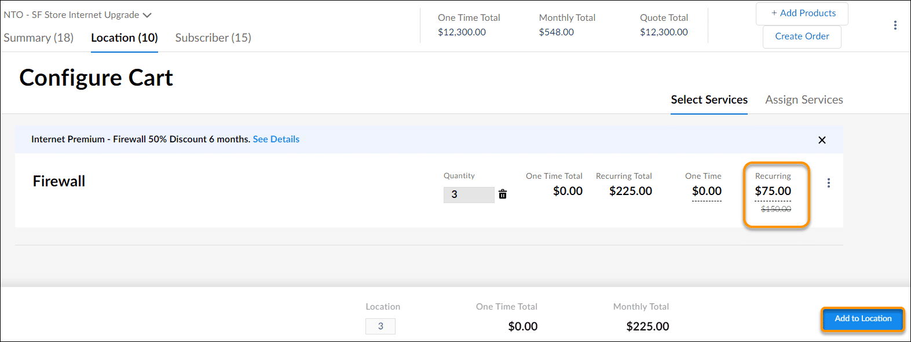

**6. View the promotions in the quote summary**

Click the **Summary**tab to view the promotions assigned to each quote member or group. 

Expand the quote line item to view details of the item.

Click **See Details** to the right of the promotion name in the quote line item details to view details specifically about the promotion.

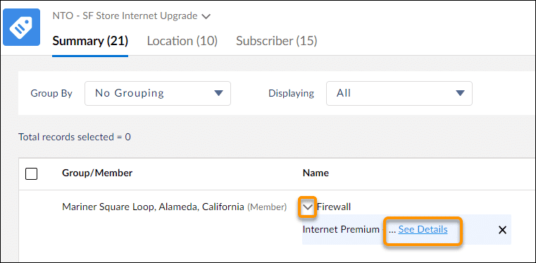

Delete a Promotion  
To delete a promotion from the quote summary, click the X to the right of the promotion name in the quote line item.

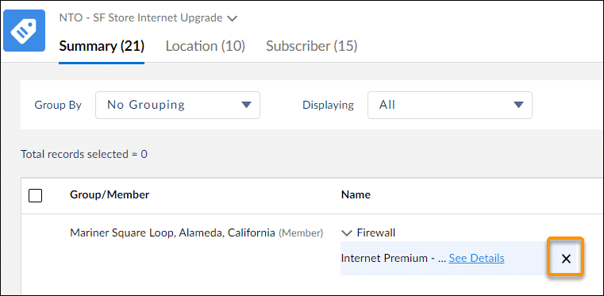

Adjust the Price of a Quote  
The offers available in ESM include detailed pricing adjustments and promotions built in the shared catalog using Industries CPQ's pricing definitions. You can further adjust pricing by:

* Overriding a price when configuring a product in the Cart.
* Selecting Adjust Price while configuring a product in the Cart.

To replace a one-time or recurring price, use pricing overrides. To apply a percentage adjustment or value adjustment, such as a discount, use the Adjust Price option.

Prices are overridden or adjusted during product configuration. Amend prices you have already configured by editing the product from the quote summary.

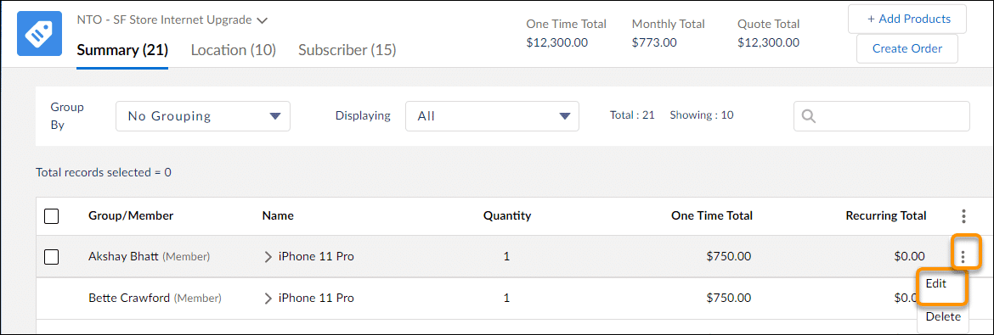

Price Overrides  
A price override replaces the existing price with a new value. In this example, you use a price override to offer one subscriber his iPhone 11 Pro for the reduced price of $695.

To override a price when configuring the product, type the new one-time charge or recurring charge in the associated underlined field. To view your change, click elsewhere on the pane.

The price is updated, and the original price is shown, struck through, underneath.

Click **Add to Product**to apply the changes to your quote line item. The line item price is updated in the quote summary.

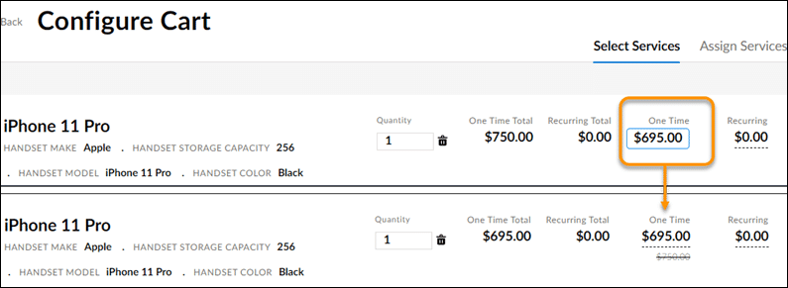

Contract-Based Pricing  
With contract-based pricing, a frame agreement determines the price of a product. A frame agreement is an overarching contract covering key elements such as pricing, discount terms, and other contractual terms such as service level agreements.

When you select a product in ESM, the selection page displays the base price, without any adjustments. Once the product is added to the Cart, the configuration page and summary page display the price determined by the frame agreement.

Learn more about frame agreements and contract-based pricing in the Contract Lifecycle Management course, available in Vlocity University and Partner Learning Camp.

Task four of the next exercise guides you through amending a contract to provide a reduced price for any iPhone 11 Pros ordered by Acme this year. Complete the exercise to gain a better understanding of how to use frame agreements with ESM.

ESM Proposals  
An ESM proposal is a document that outlines the contents of the quote. Proposal templates are provided with ESM. Your administrators and developers can adapt these templates to suit your company’s requirements.

There are a few tools available to help you navigate your proposal. For example, out of the box you click the 🔍 icon to search for specific text within your proposal, and the menu icon gives you the option to switch to full screen. Your ESM developers can extend the menu and the icons offered to provide more functions if required

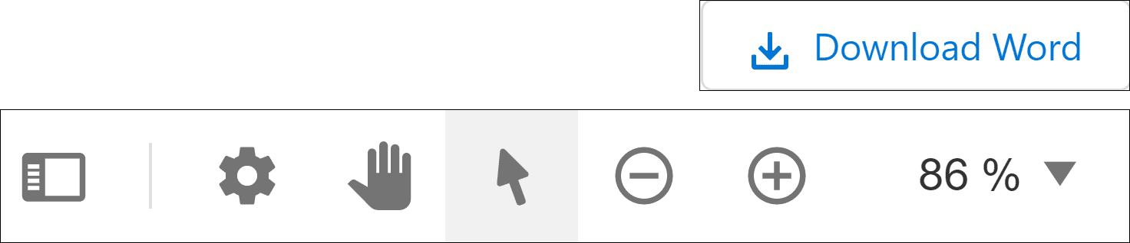

When you're finished viewing the proposal, click **Done**at the bottom of the page.

Proposals are stored on the quote. To view a proposal previously created for a quote, open the quote and scroll to the **Related**sub-tab, **Notes and Attachments** section.

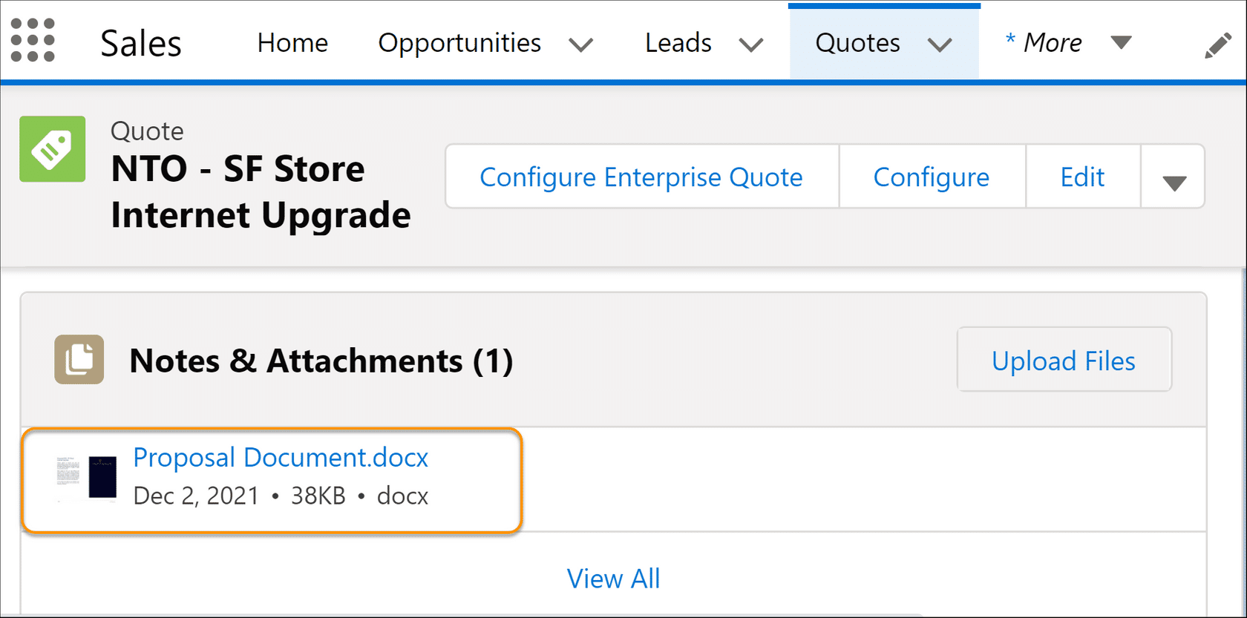

Create an Order  
The order-creation process is easy. Open your quote, go to the **Summary**tab, and click **Create Order**(either the button or the menu option is fine).

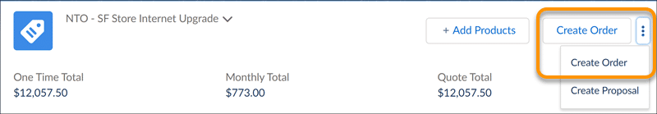

Although it looks easy on the surface, ESM does lots of work behind the scenes. What happens when you click the**Create Order** button?

The order is created, and you see an order page. ESM creates a primary order, associated with the business account record, and then creates associated suborders for each quote member.

To see the suborders, open the first order created as part of the process. View the **Orders**section of the **Related**tab to see the associated suborders. If there are products that aren’t associated with any groups or quote members, a suborder is created for the business account that includes the products. Look at this example.

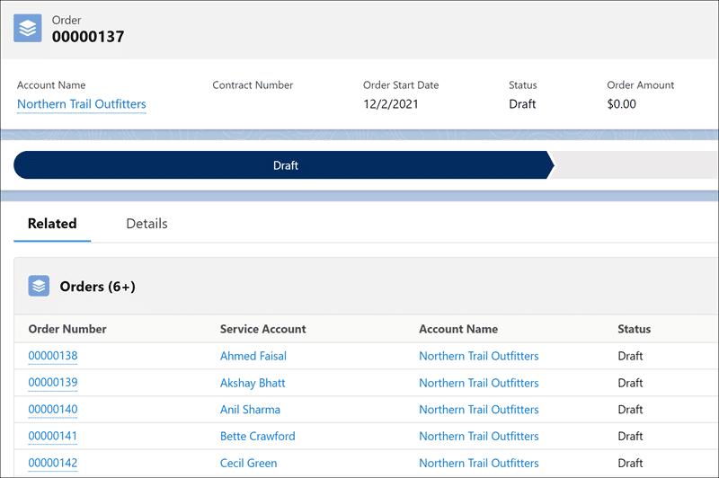

Order 00000137 is the order record. This was the first order created when **Create Order** was clicked, so it is the primary order. On the **Related**tab for the primary order, you can see all the associated suborders.

ESM creates service accounts for each quote member without a service account. The products ordered for the service account are displayed on the service account record in Salesforce.

There’s a lot that happens when you create your order, and for very large quotes it may take some time for the process to complete. Refresh the order for an up-to-date view of the orders created so far.

Submit Your Order  
You’ve checked your orders and suborders, and everything looks good. Now it’s time to submit the order to your order-management system and start the order-fulfillment process. There are two options here:

* Whole order submission: If your customer is happy to have their entire order processed at once, submit the primary order. This submits all the sub-orders to order management as one process.
* Partial order submission: Your customer may want only selected sub-orders to be processed now, and the rest at a later date.

Submit the Whole Order  
To submit all suborders at once, open the primary order, and click **Submit Orders**.

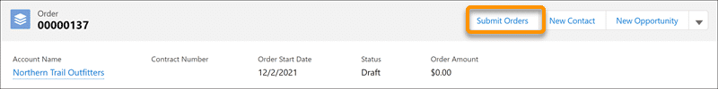

All the suborders are queued for submission to the order-management system, and ESM creates their assets. You receive a confirmation message once the order submission is complete.

Submit Selected Sub-Orders  
Take a look at one of your suborders. Click the order number to open the order record in Salesforce.

**1. Configure the suborder**

If you want to add specific technical information to the order before submission, from the dropdown menu in the top right, select **Configure**. Then add the required details.

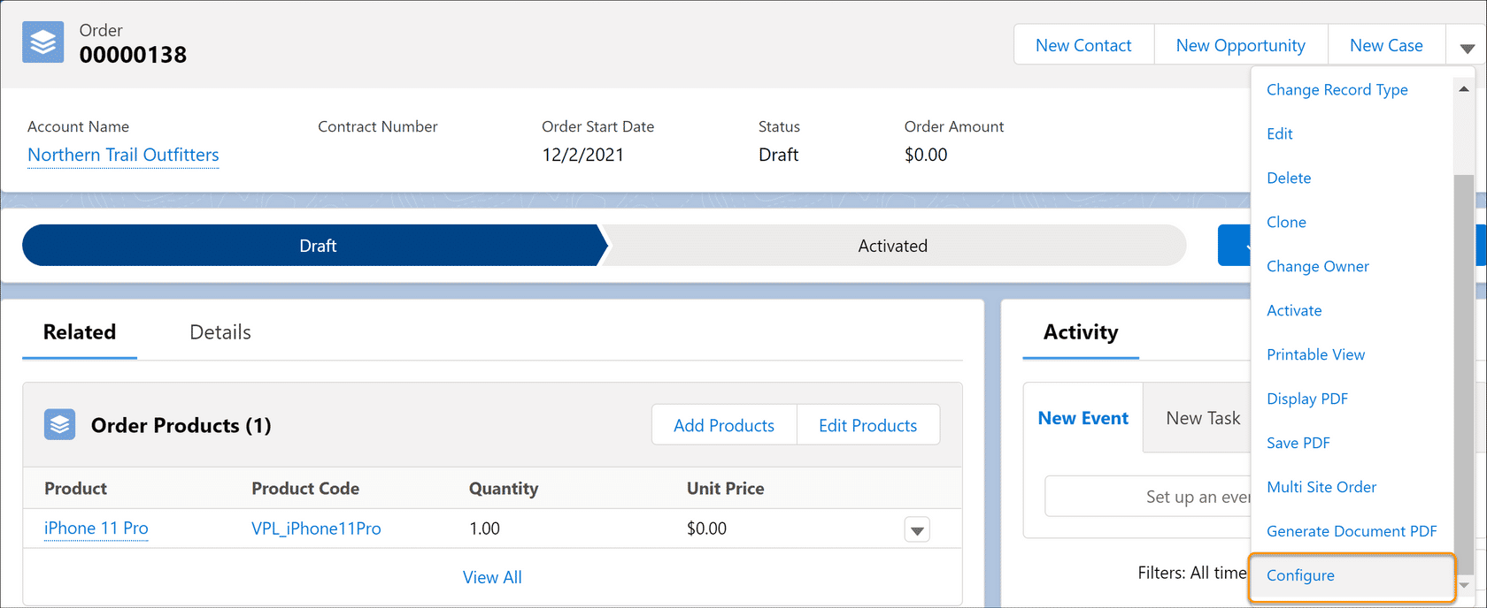

**2. Submit the suborder**

Notice the suborder is clearly marked as a sub-order in the header. Once you’re happy that all the appropriate information is included, click Submit Order. ESM submits the suborder to the order-management system.

Next, ESM creates assets and associates them with the business account and service account related to this suborder. Once the assets are associated, you receive a message confirming the order submission has been successful.

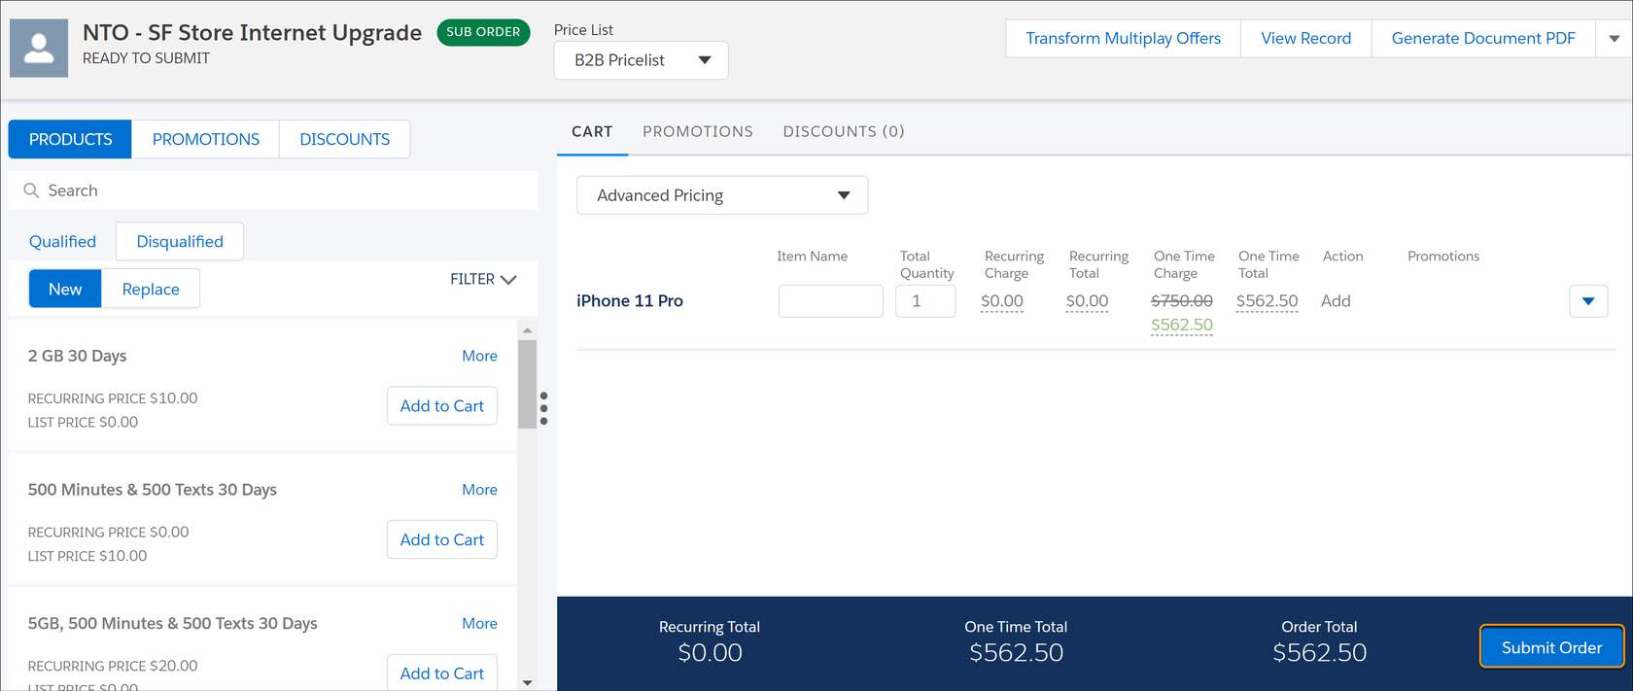

**3. Review submitted suborders**

Return to the primary order, and you can see at a glance which of your suborders have been submitted and activated and which are still pending submission.

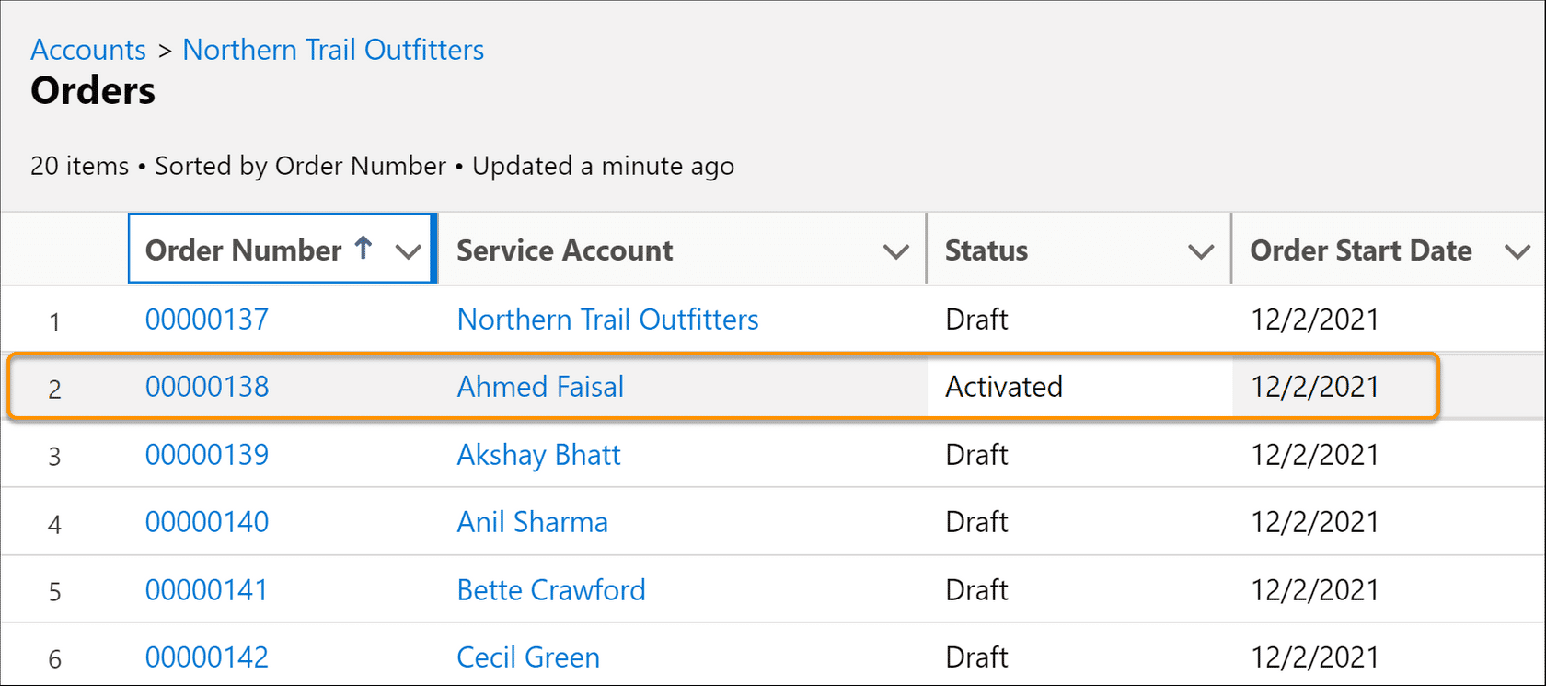

# Support Your Sales Process with Analytics (optional) skipped this module